**Software Engineering Challenge**

**Requirements**

Describe the challenge or problem, what does the program need to do

The challenge is to make a cityscape with blinking lights and other animations in it. It will have to draw a landscape, some windows and people walking the street

What classes/objects do you think you need?

I will need classes to make the windows and the people making it

How much time do you think you will you need to complete the project?

6 days

**Research**

What knowledge or skills will you need to build this program

I will need to know how to make certain shapes, change colors and make things move across the screen

Do you foresee any problems or constraints, describe

I see a problem with how I will make people walk from left to write and an animation for it, how to make lights turn on and off, and making a day and night cycle

Have you created a similar programs? Are there similar programs in the book or other resources?

If so, what elements of that project can you bring to this project?

I have used the turtle program to draw lines and stuff last semester, I can use knowledge of trigonometry to oscillate things

Do you have the resources you need to create the program?

Yes. There are templates and classes already made

Do you need to learn any new knowledge or skill(s) to create the program?

I need to know how to draw things with this new program and classes

**Design**

Draw/create a basic graphic you plan to build - attach the drawing

(paint, word, photo shop) not every objet (draw one example although there may be several in the final program) needs to be in the basic graphic

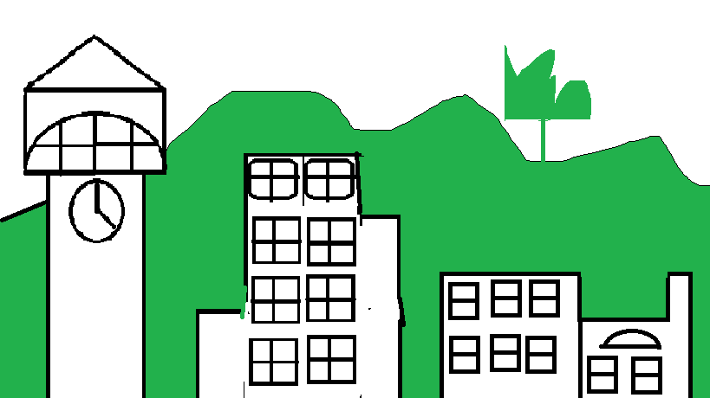

Include a task list--what will you need to do and in what order

1. Draw the buildings
2. Draw the landscape
3. Draw the windows and make sure they turn on and off
4. Draw people parachuting from the sky

Estimate the amount of time you will need to complete each part the project

1 day each

**Construction – included in summary doc**

Document your construction progress with date and progress made (build a chart/table in word or excel), also, include at least three screen shots of your city (beginning, middle, and end)

**Testing/Results/Delivery—summary doc not required to start project**

Preliminary testing

Does your program meet the needs of the initial challenge or problem? How do you know?

Are any changes or modifications needed, why or why not? Document any changes.

Summarize the project - what worked, what didn’t work, note your successes and/or failures.

Looking back, would you have done anything differently, why or why not

Software Summary Document

Daily Progress Report

|  |  |
| --- | --- |
| Date | Description |
| January 13, 2023 | I figured out how each part of the program worked, I added a circle on my own, which is progress |
| January 14, 2023 | I added a sun and made it go in a circle |
| January 15, 2023 | I added a sun/moon cycle and added hills |
| 1/17/23 | I added a road and a clock tower |
| 1/18/23 | I drew the rest of my buildings |
| 1/20/23 | I added a person falling straight down |